Multi-genre thematic unit

Table of Contents

Multi-genre Guide………………………………………………………………….3

Multi-genre lesson template………………………………………………………..6
Multi-genre teacher reflection
Texts and handouts for lesson

– Content Area Literacy Multi-genre Thematic [Content Area & Literacy] Unit Planning Guide
(Source – MPE Regional Training: Common Core and ELA)

NAME:

CONTENT AREA/SUBJECT: Science GRADE LEVEL/COURSE: 8th

What is the topic/big idea for this content area unit? Cells in Life

What is the essential question for the unit (real-world connection)?

- How are plant and animal cells different?
- What are the functions of the organelles in plant and animal cells?
- What organelles are only found in plant cells?

CONTENT AREA Standards selected for this unit:
3.b. Compare and contrast the major components and functions of different types of
cells. (DOK 2)
- Differences in plant and animal cells
- Structures (nucleus, cytoplasm, cell membrane, cell wall, mitochondrion, and nuclear membrane)
- Different types of cells and tissues (e.g., epithelial, nerve, bone, blood, muscle)

LITERACY [ELA] Standards selected for this unit:
CCSS.ELA-LITERACY.L.9-10.4.A
Use context (e.g., the overall meaning of a sentence, paragraph, or text; a word's position or function in a sentence) as a clue to the meaning of a word or phrase.

CCSS.ELA-LITERACY.CCRA.R.1
Read closely to determine what the text says explicitly and to make logical inferences from it; cite specific textual evidence when writing or speaking to support conclusions drawn from the text.
CCSS.ELA-LITERACY.CCRA.R.2
Determine central ideas or themes of a text and analyze their development; summarize the key supporting details and ideas.
CCSS.ELA-LITERACY.CCRA.R.10
Read and comprehend complex literary and informational texts independently and proficiently.
CCSS.ELA-LITERACY.CCRA.L.4
Determine or clarify the meaning of unknown and multiple-meaning words and phrases by using context clues, analyzing meaningful word parts, and consulting general and specialized reference materials, as appropriate.
CCSS.ELA-LITERACY.CCRA.L.6
Acquire and use accurately a range of general academic and domain-specific words and phrases sufficient for reading, writing, speaking, and listening at the college and career readiness level; demonstrate independence in gathering vocabulary knowledge when encountering an unknown term important to comprehension or expression.

ANCHOR TEXT
Provide complete citation.
Anchor text is used to model comprehension skills and strategies.
Cells the Building Blocks of Living Things by Cindy Sherwood

Fictional selection:
The Cells Around Us by ReadWorks http://www.readworks.org/passages/cells-make-us (readworks, 2017)

Non-fiction selection [science-based OR historical-based text required]:

https://owlcation.com/stem/Plant-Cells-vs-Animal-Cells-With-Diagrams (nunes, 2016)

Text through pictures:
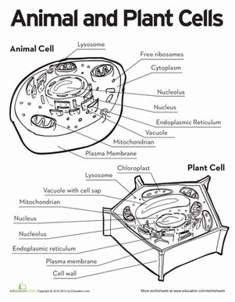

Media text (audio/visual):
https://youtu.be/URUJD5NEXC8 (Media, 2015)

(teacher, 2011)

(all, 2015)

(TV, 2016)

Multi-Genre Thematic (Content Area & Literacy) Unit Plan

LESSON PHASES | DAY 1 CONTENT FOCUS: | DAY 2 CONTENT FOCUS:
1. Introductory – Before Learning/Reading Phase | TTW ask students what they know about cells.  TTW divide the class into pairs and instruct them to compose a K-W-L chart.  The students are asked to explain everything they know about cells, what they would like to know and what they learned at cells. | TTW show the students the picture of the plant and animal cell.  She would then explain that they are going to learn about how these cells work, but before we read about them I think that it would be good to see how these cells look. Sometimes when a picture is associated with a term it is easier to remember and understand.
2. Developmental – During  Learning/Reading Phase:  Teacher Facilitation | TTW ask what are somethings we see that are different about the cells?  What things are composed of cells?  What are cells?  TTW have students read aloud text. | TTW ask what are somethings we see that are different about the cells?  Let’s look at the names of the organelles of the cells. Organelles are the different parts the cells are composed of. Let’s look at the name of the organelles do you see something that is the same with both cells? Do you see something different?  Let’s look at the picture of the organelles now. Do they look the same in each cell?
3. Developmental – During or  After Learning/Reading Phase:  Student Engagement and  Response | TSW complete a K-W-L chart  TSW read aloud text and complete activity. | TSW complete a Venn diagram of the cell pictures
4. Concluding – After Learning/Reading Phase | Now that we have read about cells, let’s talk about what makes our cells different from plant cells. | Now that we have seen what each cell looks like it is time to read some about them.
*Replicate as needed for additional days of the unit.

Multi-Genre Thematic (Content Area & Literacy) Unit Plan

LESSON PHASES | DAY 3 CONTENT FOCUS: | DAY 4 CONTENT FOCUS:
1. Introductory – Before Learning/Reading Phase | Why are cells important? Today we are going to read a text that tells us the exact answer to this question. | What did we read about yesterday? Well, today we are going to complete a webquest about cells. A webquest is simply research on a specific topic to answer certain questions we have or to complete a project.
2. Developmental – During  Learning/Reading Phase:  Teacher Facilitation | TTW have students to read the text aloud. “The cells that make us” by Readworks  While the text is being read, the teacher will ask questions.  - According to Mike’s mom, what is a cell?  - How does Mike’s mom compare the nuclear membrane and the cell membrane?  - Why do tissues “team up” to form organs? | TTW show the web quest to the class on the smartboard and go over the instructions that they need to do to complete.  TTW give the students will be given a rubric to make sure they know what they need to do to receive a 100
3. Developmental – During or  After Learning/Reading Phase:  Student Engagement and  Response | TSW read aloud the text.  TSW answer questions.  TSW complete text flip able about text. | TSW complete their web quests.  http://zunal.com/webquest.php?w=71992
4. Concluding – After Learning/Reading Phase | TTW have students to answer: What was the passage mainly about?  Why are all the part of the cell necessary? | TSW turn in their web quest.  TTW go over the answers to the web quest sheet by asking the students to provide the answers they found
*Replicate as needed for additional days of the unit.

Multi-Genre Thematic (Content Area & Literacy) Unit Plan

LESSON PHASES | DAY 5 CONTENT FOCUS: | DAY 6 CONTENT FOCUS:
1. Introductory – Before Learning/Reading Phase | We have been learning about plant and animal cells. So today, we will watch a video about animal cells. | Yesterday we watched a video about animal cells. So today we are going to compose an interactive notebook.
2. Developmental – During  Learning/Reading Phase:  Teacher Facilitation | TTW show students the video about animal cells.  This video has a lot of information in it and to make sure you focus on what is the important information. You will have to answer the following questions while watching the video. | TTW will pull sticks to call students to read text aloud.
3. Developmental – During or  After Learning/Reading Phase:  Student Engagement and  Response | TSW answer questions about the video.  TSW share their responses to the questions with the class. | TSW will read the text aloud and construct interactive notebook pages.  TSW complete a likert scale.
4. Concluding – After Learning/Reading Phase | After watching the video, what was something that you learned that you did not know before? | After reading the text, what is complete a likert scale.
*Replicate as needed for additional days of the unit.

Multi-Genre Thematic (Content Area & Literacy) Unit Plan

LESSON PHASES | DAY 7 CONTENT FOCUS: | DAY 8 CONTENT FOCUS:
1. Introductory – Before Learning/Reading Phase | What is your heart’s job inside of your body? What about your lungs? What about your brain? Just like all of those body parts perform a job that keeps our bodies working. Organelles do the same thing for cells. Today we will look more into their functions. | Yesterday we completed an organelle function checklist, who can name a organelle and it function. Today, we are going to label the a few organelles inside of a plant and animal cell.
2. Developmental – During  Learning/Reading Phase:  Teacher Facilitation | TTW read the text aloud. “Looking inside cells”  TTW explain to students to write the definition to all the bold face word in the text on the bookmark to be used on the assessment.  TTW inform students that they are to research each organelle and complete the checklist of their functions. Only place a check in the boxes that describe each function of the listed organelles. | TTW have the students to choral read the text “What do Cells do”.  TTW tell students that they will have to correctly label organelles in a plant and animal cell.
3. Developmental – During or  After Learning/Reading Phase:  Student Engagement and  Response | TSW complete a vocabulary bookmark while reading the text.  TSW complete organelle function checklist. | TSW read text aloud.  TSW complete an organelle labeling activity for both cells.
4. Concluding – After Learning/Reading Phase | The students | TSW answer if they think a cell can survive without the mitochondrion.
*Replicate as needed for additional days of the unit.

Multi-Genre Thematic (Content Area & Literacy) Unit Plan

LESSON PHASES | DAY 9 CONTENT FOCUS: | DAY 10 CONTENT FOCUS:
1. Introductory – Before Learning/Reading Phase | TTW will ask students random questions about cells. | For the past two weeks, we have been learning about plant and animal cells. Today we are going to put all the information we have learned to use. We are going to construct an edible model of either a plant or animal cell.
2. Developmental – During  Learning/Reading Phase:  Teacher Facilitation | TTW divide the class into half to play cell jeopardy.  We have been learning about cells for the past two weeks now we are going to see how much we have learned. | TTW give students instructions on how to construct the edible cells.  TTW divide the class into groups by the color of their stickers they were given as they entered the classroom.
3. Developmental – During or  After Learning/Reading Phase:  Student Engagement and  Response | TSW be divided into teams and answer questions about cells for points.  TSW complete an assessment about cells. | TSW be divided into groups.  TSW pick out the items they need to construct their cells.  TSW construct a key to identify the organelles inside of their cells and explain their functions.
4. Concluding – After Learning/Reading Phase | TSW share with the class if they felt like they were prepared for the assessment and how they think they did on the assessment. | TSW compose a paper telling how life would be if the cells in our body were replaced with plant cells and if plant were composed of animal cells.
*Replicate as needed for additional days of the unit.

Teacher Reflection

Analyze your incorporation of each of the following elements of the PARCC Model Content Framework in your Multi-Genre Thematic Unit Plan. You should respond to EACH prompt given below using the ACE strategy:
  - Answer the prompt.
  - Cite specific evidence from the unit.
  - Explain how evidence supports the answer.

- Reading: Text complexity and the growth of comprehension

I utilized various texts in this unit that varied in complex. I used texts that were short, long, and easy to read. I used a text was short and easy to read because it was below the grade level I chose which was eighth grade. The text I am talking about is “Looking inside of cells” that was used on day seven. Another easy text was the text used to complete the interactive notebook pages. This text was on sixth grade level. The text that was longer in length and was more complex than the first two texts was “What do cells do” Another complex text was “The cells that make us” by Read works. This text is complex because it goes more into detail about our cells, body, tissue, and organs. “What do cells do” goes more into detail about how plant cells perform photosynthesis.

- Writing: Text types, responding to reading, and research

Writing is something that is included into every lesson. For this lesson, I incorporated writing by having students to answer open ended questions, research activities, and by writing paper. One way is when I had students to answer questions while watching the you tube video. Another was when I had my students to write a paper that explaining how life would be if we had plant cells inside of our bodies and plants had animal cells. I also allowed them to write responses to questions as closures to the activities also. When the students had to complete the web quest it allowed them the opportunity to conduct a research. It gave them a chance to use the internet and find out about organelles without me giving them the information. After they completed, the web quest I gave them the chance to share their finding with the class. Students used written language to express their opinion for several questions at the end of each lesson.

- Speaking and Listening: Flexible communication and collaboration

I always try to use speaking and listening in all my lessons. All lessons are basically speaking and listening that are occurring at different times by the teacher and students. I give students an opportunity to speak by having them work in pairs to construct a K-W-L chart and sharing their responses with their classmates. I gave the students a chance to practice listening when they watched the video on animal cells. While they were watching the video, they had to pay close attention to want was being shown on the video. The video does not have any words being spoken but the words are being shown as captions. The words on the video will help them to answer the questions they are assigned to answer while watching the video. After they answer the questions, they get to share the answers they got for each question. The students also got a chance to have class discussions and group discussions. They had group discussions when they were constructing the edible cells.

- Language: Conventions, effective use, and vocabulary

I incorporated the essential “rules” of standard written and spoken English into my unit plan by having students focus on the effective use of language when the students had to compose their own paper. They had to use language and vocabulary words to compose a paper explaining what life would be like if their bodies were composed of plant cells. They had to use English effectively to convey their thoughts about what life would have been like. They also found the meaning of several vocabulary words using text. The students had to complete a bold face vocabulary bookmark. While reading the text, they had to pick out all the bold-faced words and use context clues to figure out the meaning of each bold face word. Well they found the function of some the organelles as well as the definition to some words. Another way, I incorporated English was by having the students play jeopardy. The students used the organelles or vocabulary words to answer the jeopardy questions.

.

Day Three
The Cells that Make Us by Readworks
“Mom, I’m hurt,” said Mike.
“What happened?” asked Mike’s mom.
“I stumbled and fell while playing football at the playground today. I scraped my knee,” said Mike.
“You poor dear. Here, let’s put a Band‐Aid on your knee,” said his mom.
Mike’s mom gingerly wiped his bleeding knee with a wet cloth and pasted a Band‐Aid on it.
Mike wondered aloud, “Our bodies are made of arms and legs. The arms and legs are made of
blood and bones. But what are these blood and bones made of?”
Mike’s mom replied, “Everything in our body is made of small units called cells. Think of it this
way. Just like hundreds of thousands of bricks form a house, millions of cells form our blood,
muscles, bones, skin, and hair—eventually coming together to form the human body.”
As Mike looked at his bandaged knee, he wondered, “Wow, can I see these cells?”
.
“You cannot see your cells directly,” said his mom. “A cell is tiny and is as small as the bacteria
and other microorganisms that we cannot see with our naked eye. A cell is the smallest unit
that can be said to be alive. You can see a cell if you have a powerful enough microscope, just
like you’d see bacteria or microbes under a microscope.”
“So, every part of my body consists of cells?” Mike said.
“Yeah. Not just your body, mine too,” said Mike’s mom. “Your pet dog, Tommy? He’s made of
cells. Your friend Jim’s cat? She’s made of cells, too. The lions we saw on safari last year, the
spiders in our storeroom. Every creature on earth is made of tiny cells, just like you and me.”
“Wow, so an ant or an amoeba is built up of cells, like so many Lego blocks?”
“Yes, just like Lego blocks. Only some creatures have just a single cell, like an amoeba. They
are called unicellular organisms. Others, like us human beings, are collections of cells. These
are called multicellular organisms. Multicellular organisms can range in size from brown algae
to large animals like elephants, whales, and giraffes, which have trillions of cells.”
“But what does a cell look like?”
“A cell is tiny, of course. But if you did manage to peer into a cell with a microscope that was
powerful enough, you could see that a cell consists of different parts, too.”
“So what parts are these?”
“Just like parts of our body are responsible for different activities (legs for movement, stomach
for digestion, eyes for seeing, etc.), different parts within cells are responsible for different
functions. These different parts perform the activities that keep the cell alive.”
“Wow, so how does this teeny weeny cell stay alive?”
“The different parts of the cell work together to keep the cell alive. The nucleus is the ‘brain’ of the
cell. It controls and coordinates all activities of the cell. The nucleus is surrounded by the nuclear
membrane, which is like a blanket that protects the nucleus. The cell membrane is the outer covering
of the cell, much like the nuclear membrane is the covering of the nucleus. The cell membrane is like
a tap which controls what enters and leaves the cell. It can allow certain substances (food and water)
to enter the cell, and block out other substances (waste or poisonous substances).

“So the cell membrane is like a sieve that lets in some things and blocks other things?”
“Yeah. Or like an electric switch, if you think of it that way. Then there is the cytoplasm, which
is a jellylike fluid that fills the cell, much like blood fills our body.”
“Or like air fills the atmosphere around us?”
“Exactly! Only, all of this is within the tiny cell you can only see with the hlp of a microscope.”
“Wow. This is like a tiny machine!”
“Yeah. But that’s not all. All plant, fungal and some animal cells also have vacuoles, which is a
cavity that works like a storage container.”
“And what goes inside it?”
“It depends. Mostly, vacuoles are used to isolate harmful and waste material from the rest of
the cell and help get rid of it.”
“And what else?”
“Water; in plants, vacuoles help maintain the right water pressure. Animal cell vacuoles also
help to store fats, starches, and glycogen which are all energy products.”
“Is energy produced inside the vacuoles too?”
“No. Energy production happens in a part of the cell called the mitochondrion. These mitochondria
are shaped like kidney beans. They convert food into chemical energy for the cells.”
“And all the millions of cells keep me alive.”
“Absolutely. With the accumulated energy in every one of the millions of cells, you and I get
the strength to move our arms and legs, to think, move about, and to live.”
“Wow. But each cell is tiny, so each cell would produce only a tiny amount of energy.”
“Yeah. So these cells have to work together. A group of cells band together and form a tissue.
There are many types of tissues. For example, connective tissues include blood or bones.
These form connections between parts of the body. Muscle tissues form muscles, which help
us move. Nervous tissues help parts of our body transmit messages—or ‘think’ and react to
things that happen around us. Epithelial tissues are outer tissues that form protective layers.”
“Like, skin?”
“Exactly! These tissues are specialized for different functions, so they work together in unison.
For instance, all the cells in the muscle tissue in your calf muscles work together so that you
can walk or run.”
“…and the tissues in my biceps help me wave my hand,” said Mike, waving his hand from side
to side.
“That’s not all,” said Mike’s mom. “Often, tissues cannot function or operate by themselves.
So, these tissues team up to form organs.”
“Just like me and my friends together form a football team,” said Mike, reminded of his scraped
knee.
“Yeah, just like you can’t play football by yourself, a tissue cannot do anything by itself. It teams
up with other tissues, and together, they perform the body’s activities. So, a group of tissues
team up to form your nose and help you smell. Other tissues in your pancreas help you digest
food. So, each organ performs its specific function because of the tissues that constitute it.”
“And the tissues, of course, are formed by the teeny weeny cells. Wow, so even if a cell by
itself cannot smell anything, or a tissue by itself cannot smell anything, a collection of tissues
can actually smell? That is so cool!”
“Unless you’re a unicellular organism, one cell can’t do much on its own. But in unity, there is
strength. When millions of cells work together, magic happens. When cells combine to
become tissues and tissues combine to become organs, the organs can perform the everyday
activities like digestion, breathing, smell, taste—and just about everything else you do.”
“Wow, all because of a teeny weeny cell! That is truly magical.”

Day Four
Name __________________________________
Web quest task sheet and rubric.
Students will have to search the internet to complete these tasks.
1) Define cells
2) Define organelle
3) Discover the differences between plant and animal cells.
4) Create a compare/ contrast chart for plant and animal cells.
5) Find the functions of the different cell organelles.
6) Answer the questions posed in the introduction.
7) Create cell diagrams or models to show the plant and animal cells.

Rubric
Student Name: ________________________________________

CATEGORY | 35 | 30 | 25 | 20
Information Gathering | Accurate information taken from several sources in a systematic manner. | Accurate information taken from a couple of sources in a systematic manner. | Accurate information taken from a couple of sources but not systematically. | Information taken from only one source and/or information not accurate.
Scientific Knowledge | Explanations by all group members indicate a clear and accurate understanding of scientific principles underlying the construction and modifications. | Explanations by all group members indicate a relatively accurate understanding of scientific principles underlying the construction and modifications. | Explanations by most group members indicate relatively accurate understanding of scientific principles underlying the construction and modifications. | Explanations by several members of the group do not illustrate much understanding of scientific principles underlying the construction and modifications.
Diagram or model | Diagram is neatly done. Contains all structures from web quest. Is colored. Has easy to read key (flipchart). | Diagram is done with one or two inaccuracies. Is neat. Contains all structures. | Diagram is not neat. Has a few inaccuracies. Is missing one or two structures. lack color. | Diagram has many inaccuracies. Lacks color. Is not neat or easy to follow. Lacks a key.

Day Five
Name ____________________________ Date ___________________________
Questions about animal cell video
True or False
- The animal cell is surrounded by an impermeable cell membrane. ________
- Anything can enter and exit the animal cell if they are small? _________
What do mitochondria release? _________________
Why is ATP needed? ____________________________________________________________________________________________________________________________________________________________
What are the two types of endoplasmic reticulum? ______________________________________________________________________________
Where do the proteins go that are produced in the rough ER? ____________________________
Why are lysosomes called the suicide bags of the cells? __________________________________________________________________________________________________________________________________________________________________________________________________________________________________________
Organelle | What does this organelle do?

Organelle Function Checklist
Does this organelle: | Mitochondria | Chloroplast | Endoplasmic Reticulum | Golgi body | Ribosome | Cell wall | Cell Membrane | Nucleus | Vacuole | Vesicle | Lysosome | Cytoplasm
provide or harness energy for the cell?
transport things for the cell?

store things (water, chemicals, waste) for the cell?
protect the cell?

provide structure for the cell?

make necessary chemicals for the cell?
contain DNA for the cell?

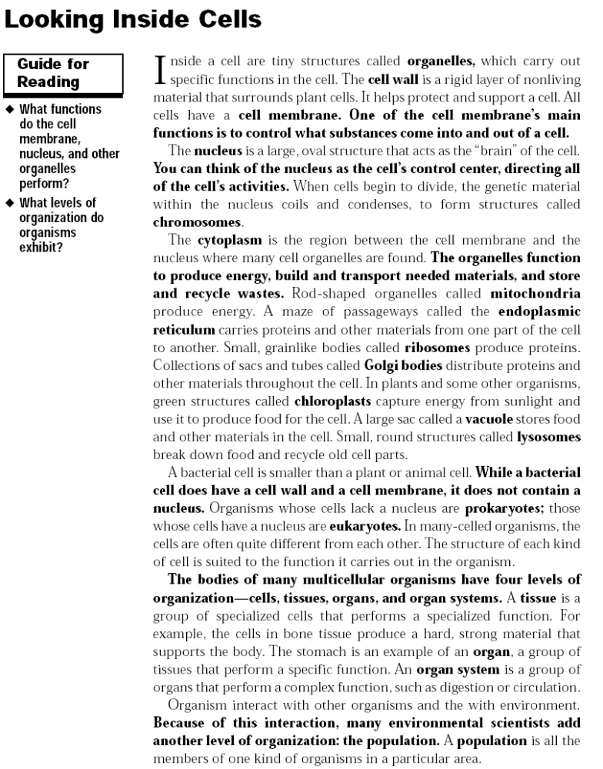
Bold Faced Word ____________________________________  Definition: | Bold Faced Word ____________________________________  Definition:
Bold Faced Word ____________________________________  Definition: | Bold Faced Word ____________________________________  Definition:
Bold Faced Word ____________________________________  Definition: | Bold Faced Word ____________________________________  Definition:
Bold Faced Word ____________________________________  Definition: | Bold Faced Word ____________________________________  Definition:
Bold Faced Word ____________________________________  Definition: | Bold Faced Word ____________________________________  Definition:

Likert Scale
Name____________________________________ Date _________________________
- Plant cells have a “blob like” shape. ________________________________________________________________________
True False
- Cell organelles perform different functions that allow the cell to function and live. ________________________________________________________________________
True False
- Cytoplasm determines what enters and exits the cell. ________________________________________________________________________
True False
- Plant cells and animal cells have all the same organelles except for three organelles. ________________________________________________________________________
True False

Animal & Plant Cells Page 1
Animals (including humans) are made up of many different types of
specialized cells (nerve cells, skin cells, blood cells, etc.), but all of these cells have a
similar structure. Animal cells have a “blob like” shape & include lots of tiny organelles
that help the cell function. Think of your own body – your body contain s organ s
(heart, liver, lungs) that allow your body to function & allow you to live. Similarly, the
cell’s organelles have different functions to help the cell do the same.
The cell membrane encloses the cell and acts like a screen to allow some
materials to pass through it but not others. Think of a screen in a window. It allows
fresh air in, but keeps bugs out! Cell membranes allow nutrients & water in while
keeping harmful molecules out! The cytoplasm is the gel-like fluid made of mostly
water that takes up most of the space inside the cell. The organelles are located in the
cytoplasm. The nucleus is an organelle that is the “brain” of the cell. The nucleus is
home to all the cell’s chromosomes. Chromosomes are genetic structures that contain
the information used to direct cell activity. Chromosomes are made of DNA.
Animal cells have many small fluid-filled structures that temporarily store
different substances needed by the cell. These structures are called vacuoles. The
mighty mitochondria are considered the “powerhouses” of the cell because they use
oxygen to transform food into energy to help the cell carry out activities. The
endoplasmic reticulum serves as an internal delivery system for cell transporting
materials the cell need s. Included in those materials are ribosomes which are tiny
organelles that make protein for the cell (think of them as little protein factories!)
Plants, trees, fruits, vegetables, and flowers are made of plant cells. Plant
cells are very similar to animal cells, but have some major differences. Animal and
plant cells both contain cytoplasm, a nucleus, mitochondria, ribosomes, vacuole,
endoplasmic reticulum, and golgi bodies. Golgi bodies help package materials from the
endoplasmic reticulum and distribute them around the cell or outside of it. Think of
golgi bodies like a post office! Both animal and plant cells are surrounded by a cell
membrane. Each similar organelle between plant and animal cells serves the same
function, but may have a slightly different structure. For example, animal cells have
multiple small vacuoles for storage while the plant cell has one very large vacuole for
storage.
There are a few important differences between animal and plant cells. First,
the structure of plant cells is more “box-like” than animal cells. If you look at plant
cells under a microscope, they look like little bricks stacked up like a wall. Animal cells
cluster together & are more circular. One reason for this shape difference is because
plant cells have a cell wall. The cell wall in a plant cell provides extra support and
structure for the cell that plant cells need. This cell wall is made mostly of cellulose,
which is a fiber that is the main component of wood and paper.
Plant cells also contain chloroplasts. Chloroplasts are organelles that help the
plant make food for itself (because plants don’t eat cheeseburgers like humans do!)
Chloroplasts contain a green pigment called chlorophyll. The chlorophyll captures the
energy of sunlight and uses it to make glucose, which is a simply sugar that plants use
as food. This process is called photosynthesis. Chloroplasts and the chlorophyll they
contain are what give plants their green color. Not all plant cells have chloroplasts (not
all plants are green!). Cells in the roots of plants, for example, are not exposed to
sunlight so they do not need chloroplasts.
Edible Cell Rubric
Names____________________________________________________
50 points | 25 points | 10 points
Students have all of the organelles represented in the cell correctly. | Students have some organelles represented incorrectly in the cell. | Students are missing organelles in the cell.
Student’s key is complete and have a representation for each organelle. | Student’s key is missing organelles representation. | Students are missing the Key to their cell.

Name __________________________________
Report Assignment
We have been learning about plant and animal cells and the function of their organelles. To better understand the way these cells function, we are going to complete a writing assignment. This writing assignment is composing a 1-1 ½ page paper about what it would be like if a plant was made of animal cells and an animal was made of plant cells. This assignment would have you incorporate your writing and comprehension skills. You can use the information you learned in class as well as use other resources for information to help complete this paper. Inside of your paper you should answer these questions:
- How would your cell get energy?
- How would the animal or plant survive given its’ new cells?
- How would the animal or plant look given the features they may receive from the cell swap?
- What life would be like without the three organelles you choose?
- Explain why it is important that plants have plant cells and animals have animal cells?
You will need to have direct information about each cell and organelles to help support your answers to each question. This assignment will consist of four parts. First, you will choose your cell. Second, you will randomly choose three organelles that your cell would be without. Third, you will compose a rough draft of your paper to be turned in to me. Fourth, you will revise your paper and correct any errors that you find while revising. Lastly, you will turn in this sheet, rubric, rough draft, and final draft of your paper.
Cell: Animal cell or plant cell
Missing organelles: _____________________________________________________________________________

Name __________________________________________
Writing Assignment Rubric
0 | 1 | 2 | 3 | 4
Student does not state the cell they chose or the missing organelles of the cell. |  | Student only states the cell and not the missing organelles. Or student only states the missing organelles and not the cell. |  | Student states the cell they chose and the missing organelles.
The student does not answer any of the questions from the writing assignment sheet. | The student only answers one of the questions from the writing assignment sheet. | The student answers 2-3 of the questions from the writing assignment sheet. | The student answers 4 of the questions from the writing assignment sheet. | The student answers all of the questions from the writing assignment sheet.
The student did not turn in their rough draft or turn in writing assignment sheet with final draft. | The student only turned in their assignment sheet but it was not filled out. | The student turned in only the completed assignment sheet. | The student turns in assignment sheet, rough draft, and final paper. | The student turned in all required information.
Student paper does not show understanding of the difference in plant and animal cells or their organelles. | Student paper show a slight misunderstanding in either the types of cells or the functions of the cells organelles. | Student paper shows they have a fair understanding of the cells and their organelles. | Student paper shows they understand the functions of the organelles of the cells. | Student paper shows that they understand the difference in plant and animal cells as well as the functions of their organelles.
The student does not stay on topic and has many grammatical errors. | Student writes about a cell or organelles that they were not assigned. | Student stays on topic but they have more than 9 errors. | Student stays on topic with more than 5 errors but less than 8 errors. | Student stays on topic with less than 5 grammatical errors.

Total points_______ x 5= __________________

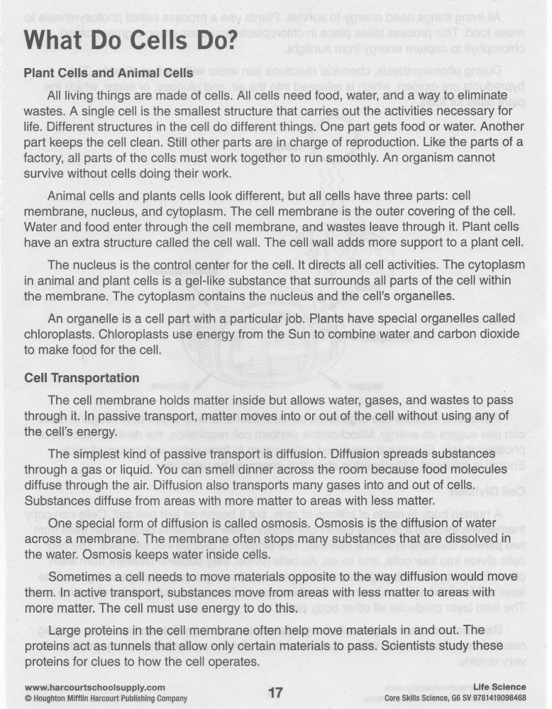
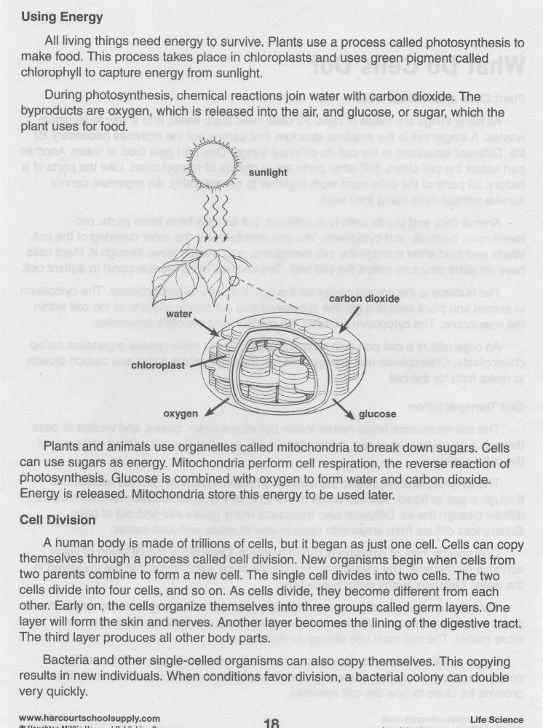
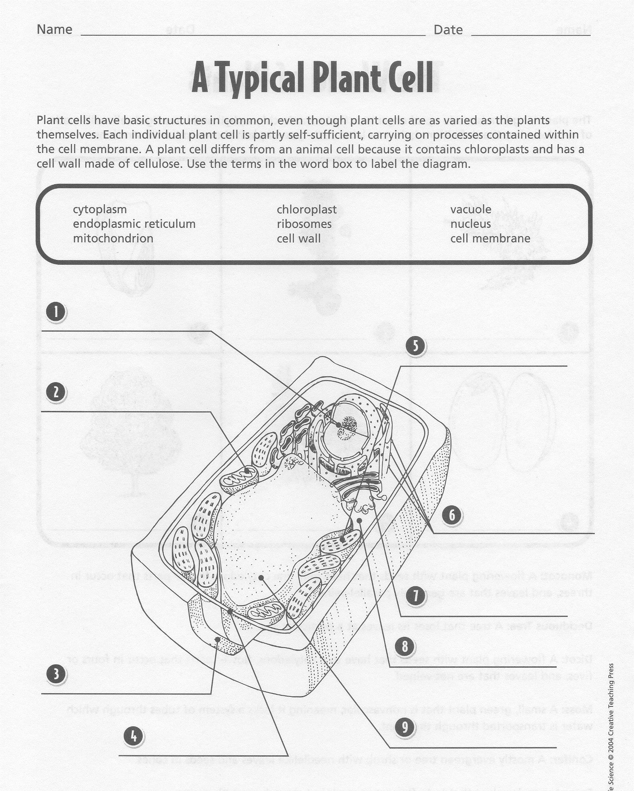

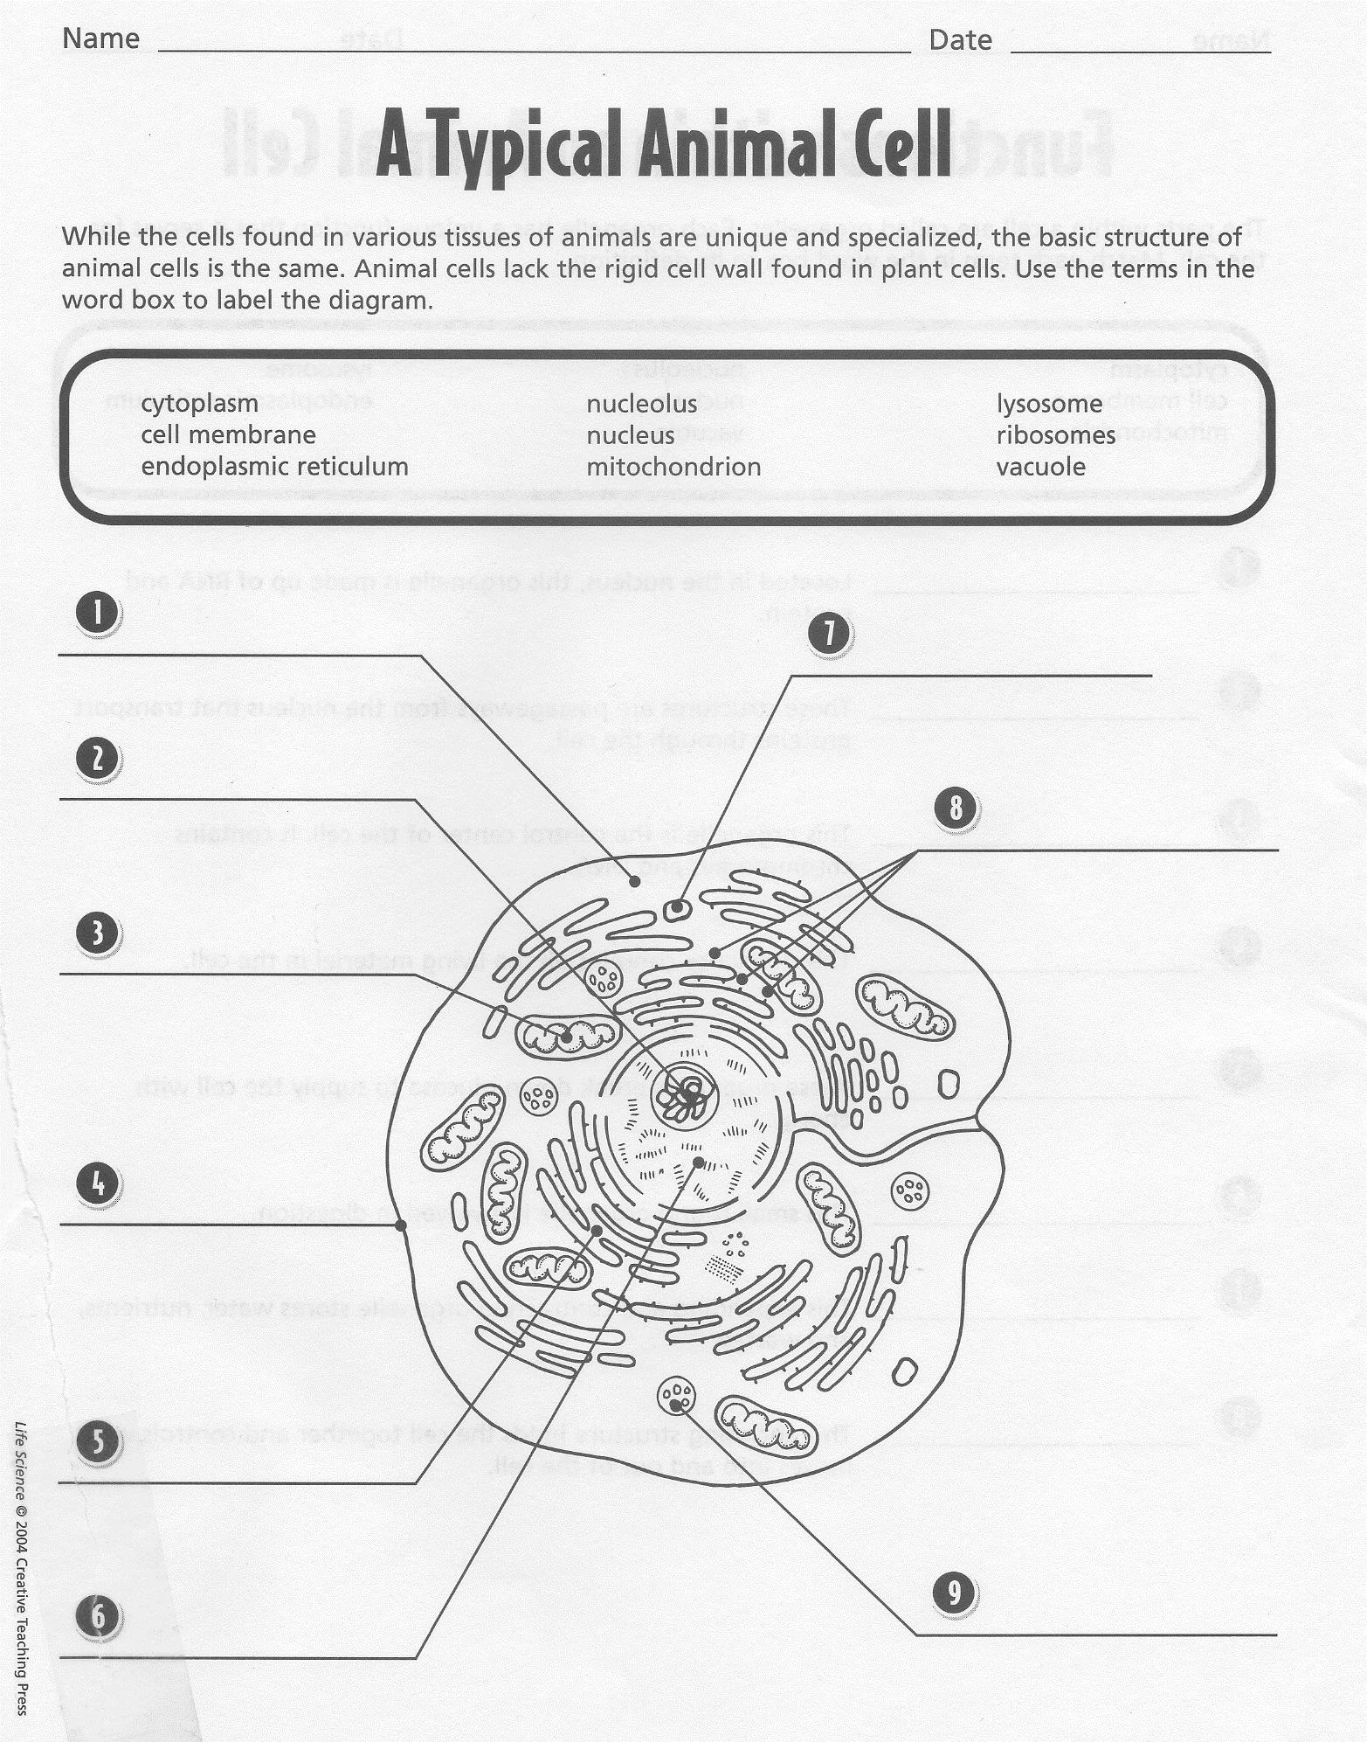

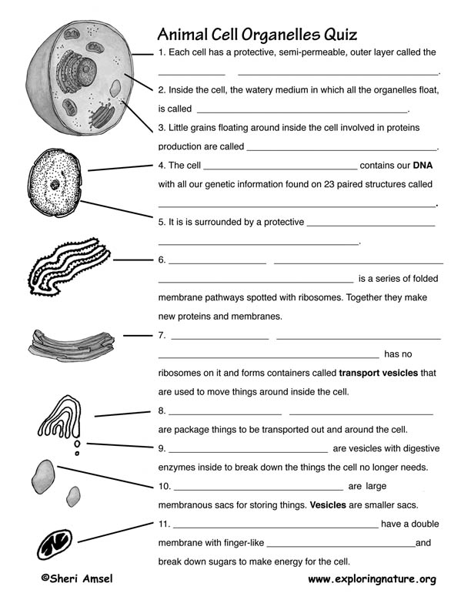

Name________________________________ Date _________________________ Pd ______
Cells Assessment
- What organelle captures energy from sunlight to produce energy? ______________________________________________________________________________
- What organelle or organelles are used to protect the cell? ______________________________________________________________________________
- Why are lysosomes called the suicide bags of the cells? __________________________________________________________________________________________________________________________________________________________________________________________________________________________________________
Tell if each statement is true or false. Circle your answer.
true | false
- The vacuole produces enymes.
true | false
- The Golgi body processes, sorts, and packages proteins and lipids.
true | false
- Ribosomes produce proteins.
true | false
- The rough endoplasmic reticulum is responsible for calcium storage and release.
true | false
- The nucleus is commonly called the control center of the cell.
true | false
- The cell wall can be found in animal cells.
true | false
- The nucleus is usually spherical and is the largest structure in the cell.
true | false
- The plasma membrane or cell membrane controls what moves into and out of the cell.
true | false
- The chloroplast is where photosynthesis occurs.
true | false
- The mitochondria does not produce ATP.
Read the following sentences from the passage: “‘Only some creatures have just a single cell, like an amoeba. They are called unicellular organisms. Others, like us human beings, are collections of cells. These are called multicellular organisms. Multicellular organisms can range in size from brown algae to large animals like elephants, whales, and giraffes, which have trillions of cells.”

- What can be concluded about cells based on this information?
- Unicellular organisms were once part of collections of cells.
- Cells in multicellular organisms are stronger than unicellular organisms.
- Cells can only support life if they are part of a multicellular organism.
- Some cells can support life independently. Other cells support life collectively.

Read the following sentences: “A group of cells band together and form a tissue.There are many types of tissues. For example, connective tissues include blood or bones. These form connections between parts of the body. Muscle tissues form muscles, which help us move. Nervous tissues help parts of our body transmit messages—or ‘think’ and react to things that happen around us.”

- Based on this information, what can you conclude about tissues?
- All tissues in the body have similar functions.
- All tissues band together to form organs.
- Each kind of tissue has a different function.
- There are only four kinds of tissues in the human body.
Exit ticket
Do you think a cell can survive without the mitochondrion? Why?
____________________________________________________________________________________________________________________________________________________________________________________________________________________________________
Exit ticket
What was the passage mainly about? ________________________________________________________________________________________________________________________________________________________
Why are all the part of the cell necessary? ________________________________________________________________________________________________________________________________________________________
Exit ticket
What was something that you learned that you did not know before? ________________________________________________________________________________________________________________________________________________________

